

Security Configuration Assessment Report for DESKTOP-JGURJJH

Target IP Address: 10.0.2.15

CIS Microsoft Windows 10 Enterprise Benchmark v4.0.0

Level 1 (L1)

Tuesday, August 12 2025 10:47:05

Assessment Duration: 1 minute, 22 seconds

Report generated by the Center for Internet Security's Configuration Assessment Tool (CIS-CAT Pro Assessor) v4.56.0.

For further information, please visit The Center for Internet Security or our Product Support page.

Copyright 02025, The Center for Internet Security

Content generated on 08/12/2025 10:48 AM. Content last obtained on 07/28/2025 16:08 PM.

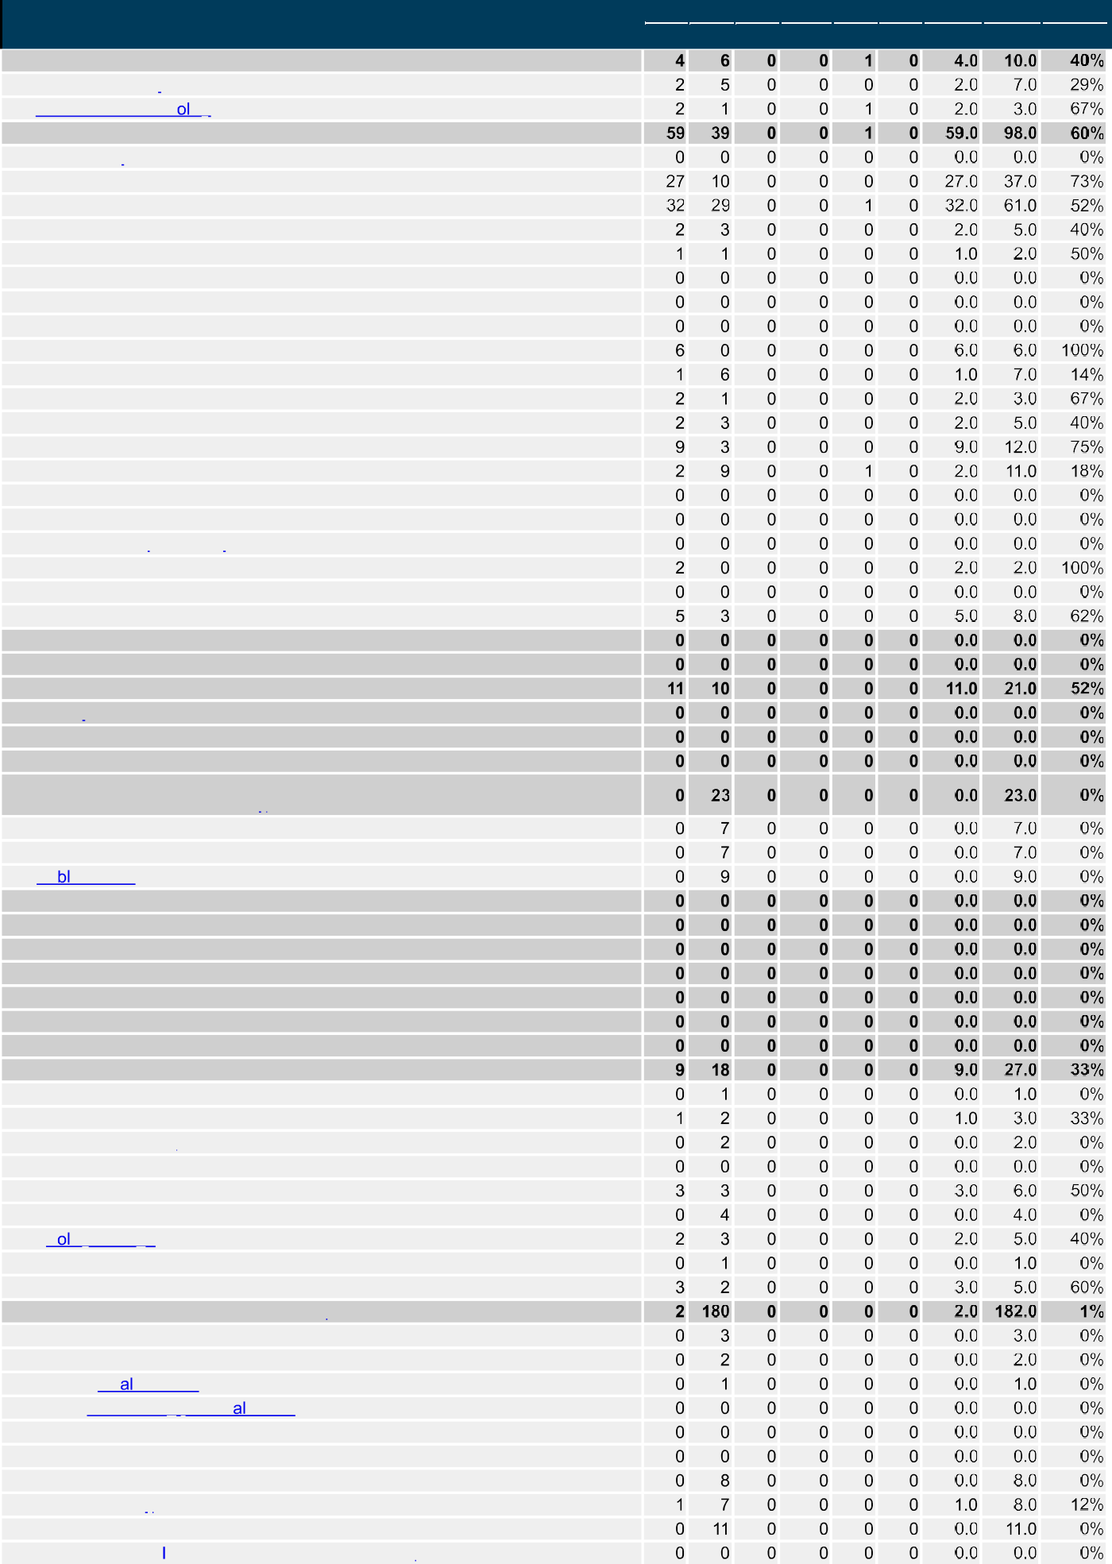

Summary

1. Account Policies
   1. Password Policy
   2. Account Lockout P icy 2 Local Policies
   3. Audit Policy
   4. User Rights Assignment
   5. Security Options
      1. Accounts
      2. Audit
      3. DCOM
      4. Devices
      5. Domain controller
      6. Domain member
      7. Interactive logon
      8. Microsoft network client
      9. Microsoft network server
      10. Network access
      11. Network security
      12. Recovery console
      13. Shutdown
      14. System cryptography
      15. System objects
      16. System settings
      17. User Account Control
2. Event Log
3. Restricted Groups
4. System Services
5. Registry
6. File System
7. Wired Network (IEEE 802.3) Policies
8. Windows Defender Firewall with Advanced Security (formerly Windows Firewall with Advanced Security)
   1. Domain Profile
   2. Private Profile
   3. Pu ic Profile
9. Network List Manager Policies
10. Wireless Network (IEEE 802.11) Policies
11. Public Key Policies
12. Software Restriction Policies
13. Network Access Protection NAP Client Configuration
14. Application Control Policies
15. IP Security Policies
16. Advanced Audit Policy Configuration
    1. Account Logon
    2. Account Management
    3. Detailed Tracking
    4. DS Access
    5. Logon/Logoff
    6. Object Access
    7. P icy Change
    8. Privilege Use
    9. 3ystem
17. Administrative Templates (Computer)
    1. Control Panel
       1. Personalization
       2. Region and Language Options
          1. Handwriting person ization
    2. Desktop
    3. LAPS (legacy)
    4. MS Security Guide
    5. MSS (Legacy)
    6. Network
       1. Background ntelligent Transfer Service (BITS)

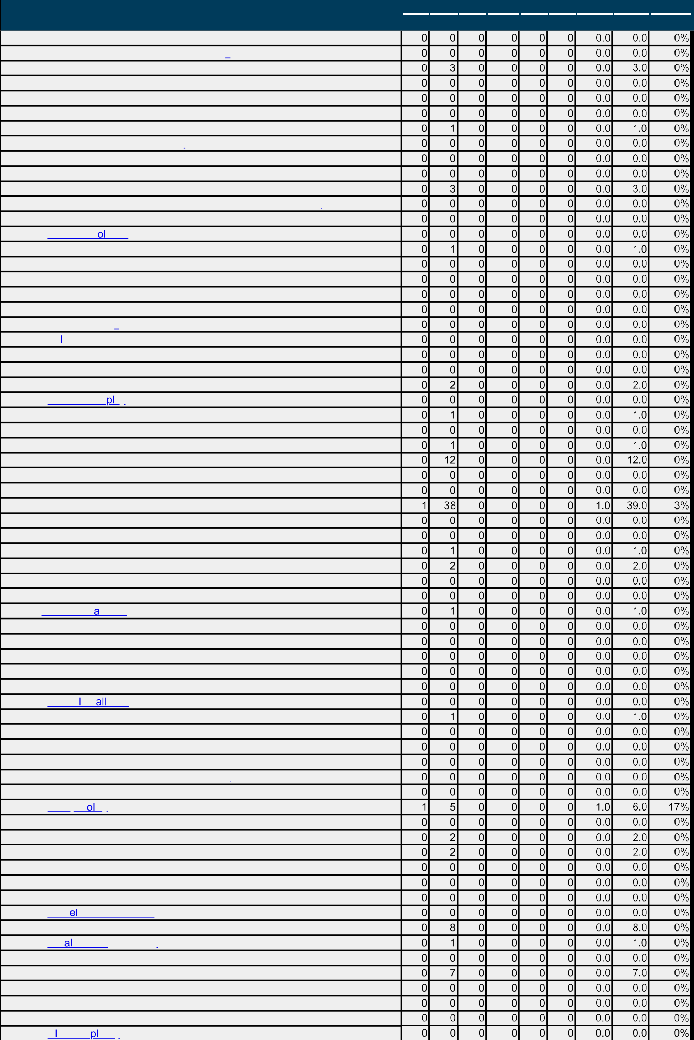

* + 1. BranchCache
    2. DirectAccess Client Experience Settings
    3. DNS Client
    4. Fonts
    5. Hotspot Authentication
    6. Lanman Server
    7. Lanman Workstation
    8. Link-Layer Topology Discovery
    9. Microsoft Peer-to-Peer Networking Services
       1. Peer Name Resolution Protocol
    10. Network Connections
        1. Windows Defender Firewall (formerly Windows Firewall)
    11. Network Connectivity Status Indicator
    12. Network Is ation
    13. Network Provider
    14. Offline Files
    15. QoS Packet Scheduler
    16. SNMP
    17. SSL Configuration Settings
    18. TCPIP Settings
        1. Pv6 Transition Technologies
        2. Parameters
    19. Windows Connect Now
    20. Windows Connection Manager
    21. Wireless Dis ay
    22. WLAN Service
        1. WLAN Media Cost
        2. WLAN Settings
  1. Printers
  2. Start Menu and Taskbar
     1. Notifications
  3. System
     1. Access-Denied Assistance
     2. Agp-V
     3. Audit Process Creation
     4. Credentials Delegation
     5. Device Guard
     6. Device Health Attestation Service
     7. Device Inst Ilation
        1. Device Installation Restrictions
     8. Disk NV Cache
     9. Disk Quotas
     10. Display
     11. Distributed COM
     12. Driver nst ation
     13. Early Launch Antimalware
     14. Enhanced Storage Access
     15. File Classification Infrastructure
     16. File Share Shadow Copy Provider
     17. Filesystem (formerly NTFS Filesystem)
     18. Folder Redirection
     19. Group P icy
         1. Logging and tracing
     20. Internet Communication Management
         1. Internet Communication settings
     21. iSCSI
     22. KDC
     23. Kerberos
     24. Kern DMA Protection
     25. LAPS
     26. Loc Security Authority
     27. Locale Services
     28. Egon
     29. Mitigation Options
     30. Net Logon
     31. OS Policies
     32. P N Com exity



|  |  |  |  |  |  |  |  |  |  |  |  |  |  |  |  |
| --- | --- | --- | --- | --- | --- | --- | --- | --- | --- | --- | --- | --- | --- | --- | --- |
| 18.9.33 Power Management | | | | | | |  |  |  |  |  |  |  |  |  |
| 18.9.33.1 Button Settings | | | | | | |  |  |  |  |  |  |  |  |  |
| 18.9.33.2 Energy Saver Settings | | | | | | |  |  |  |  |  |  |  |  |  |
| 18.9.33.3 Hard Disk Settings | | | | | | |  |  |  |  |  |  |  |  |  |
| 18.9.33.4 Notification Settings | | | | | | |  |  |  |  |  |  |  |  |  |
| 18.9.33.5 Power Throttling Settings | | | | | | |  |  |  |  |  |  |  |  |  |
| 18.9.33.6 Sleep Settings | | | | | | |  |  |  |  |  |  |  |  |  |
| 18.9.34 Recovery | | | | | | |  |  |  |  |  |  |  |  |  |
| 18.9.35 Remote Assistance | | | | | | |  |  |  |  |  |  |  |  |  |
| 18.9.36 Remote Procedure Call | | | | | | |  |  |  |  |  |  |  |  |  |
| 18.9.37 Removable Storage Access | | | | | | |  |  |  |  |  |  |  |  |  |
| 18.9.38 Scripts | | | | | | |  |  |  |  |  |  |  |  |  |
| 18.9.39 Security Account Manager | | | | | | |  |  |  |  |  |  |  |  |  |
| 18.9.40 Server Manager | | | | | | |  |  |  |  |  |  |  |  |  |
| 18.9.41 Service Contr | | | Manager Settings | | | |  |  |  |  |  |  |  |  |  |
| 18.9.42 Shutdown | | | | | | |  |  |  |  |  |  |  |  |  |
| 18.9.43 Shutdown Options | | | | | | |  |  |  |  |  |  |  |  |  |
| 18.9.44 Storage Health | | | | | | |  |  |  |  |  |  |  |  |  |
| 18.9.45 Storage Sense | | | | | | |  |  |  |  |  |  |  |  |  |
| 18.9.46 System Restore | | | | | | |  |  |  |  |  |  |  |  |  |
| 18.9.47 Trou | | eshooting and Diagnostics | | | | |  |  |  |  |  |  |  |  |  |
| 18.9.47.1 Ap | | ication Compatibility Diagnostics | | | | |  |  |  |  |  |  |  |  |  |
| 18.9.47.2 Corrupted File Recovery | | | | | | |  |  |  |  |  |  |  |  |  |
| 18.9.47.3 Disk Diagnostic | | | | | | |  |  |  |  |  |  |  |  |  |
| 18.9.47.4 Fault Tolerant Heap | | | | | | |  |  |  |  |  |  |  |  |  |
| 18.9.47.5 Microsoft Support Diagnostic Tool | | | | | | |  |  |  |  |  |  |  |  |  |
| 18.9.47.6 MSI Corrupted File Recovery | | | | | | |  |  |  |  |  |  |  |  |  |
| 18.9.47.7 Scheduled Maintenance | | | | | | |  |  |  |  |  |  |  |  |  |
| 18.9.47.8 Scripted Diagnostics | | | | | | |  |  |  |  |  |  |  |  |  |
| 18.9.47.9 Windows Boot Performance Diagnostics | | | | | | |  |  |  |  |  |  |  |  |  |
| 18.9.47.10 Windows Memory Leak Diagnosis | | | | | | |  |  |  |  |  |  |  |  |  |
| 18.9.47.11 Windows Performance PerfTrack | | | | | | |  |  |  |  |  |  |  |  |  |
| 18.9.48 Trusted Platform Module Services | | | | | | |  |  |  |  |  |  |  |  |  |
| 18.9.49 User Profiles | | | | | | |  |  |  |  |  |  |  |  |  |
| 18.9.50 Windows File Protection | | | | | | |  |  |  |  |  |  |  |  |  |
| 18.9.51 Windows Time Service | | | | | | |  |  |  |  |  |  |  |  |  |
| 18.9.51.1 Time Providers | | | | | | |  |  |  |  |  |  |  |  |  |
| 18.10 Windows Components | | | | | | |  |  |  |  |  |  |  |  |  |
| 18.10.1 ActiveX Installer Service | | | | | | |  |  |  |  |  |  |  |  |  |
|  |  |  |  |  |  |  |  |  |
| 18.10.2 Add features to Windows 10 (formerly Windows Anytime Upgrade) | | | | | | |  |  |  |  |  |  |  |  |  |
| 18.10.3 App and Device Inventory | | | | | | |  |  |  |  |  |  |  |  |  |
| 18.10.4 App Package De | | | | oyment | | |  |  |  |  |  |  |  |  |  |
| 18.10.5 App Privacy | | | | | | |  |  |  |  |  |  |  |  |  |
| 18.10.6 App runtime | | | | | | |  |  |  |  |  |  |  |  |  |
| 18.10.7 Ap | ication Compatibi | | | | ity | |  |  |  |  |  |  |  |  |  |
| 18.10.8 AutoPlay P icies | | | | | | |  |  |  |  |  |  |  |  |  |
| 18.10.9 Biometrics | | | | | | |  |  |  |  |  |  |  |  |  |
| 18.10.9.1 Facial Features | | | | | | |  |  |  |  |  |  |  |  |  |
|  |  |  |  |  |  |  |  |  |
| 18.10.10 BitLocker Drive Encryption | | | | | | |  |  |  |  |  |  |  |  |  |
|  |  |  |  |  |  |  |  |  |
| 18.10.10.1 Fixed Data Drives | | | | | | |  |  |  |  |  |  |  |  |  |
| 18.10.10.2 Operating System Drives | | | | | | |  |  |  |  |  |  |  |  |  |
| 18.10.10.3 Removable Data Drives | | | | | | |  |  |  |  |  |  |  |  |  |
| 18.10.11 Camera | | | | | | |  |  |  |  |  |  |  |  |  |
| 18.10.12 Chat | | | | | | |  |  |  |  |  |  |  |  |  |
| 18.10.13 Cloud Content | | | | | | |  |  |  |  |  |  |  |  |  |
| 18.10.14 Connect | | | | | | |  |  |  |  |  |  |  |  |  |
| 18.10.15 Credential User Interface | | | | | | |  |  |  |  |  |  |  |  |  |
|  |  |  |  |  |  |  |  |  |
| 18.10.16 Data Collection and Preview Builds | | | | | | |  |  |  |  |  |  |  |  |  |
| 18.10.17 D | ivery Optimization | | | | | |  |  |  |  |  |  |  |  |  |
| 18.10.18 Desktop App | | | nster | | | |  |  |  |  |  |  |  |  |  |
| 18.10.19 Desktop Gadgets | | | | | | |  |  |  |  |  |  |  |  |  |
| 18.10.20 Desktop Window Manager | | | | | | |  |  |  |  |  |  |  |  |  |
| 18.10.21 Device and Driver Compatibility | | | | | | |  |  |  |  |  |  |  |  |  |
| 18.10.22 Device Registration (formerly Work | | | | | | ace Join) |  |  |  |  |  |  |  |  |  |
| 18.10.23 Digital Locker | | | | | | |  |  |  |  |  |  |  |  |  |
| 18.10.24 Edge UI | | | | | | |  |  |  |  |  |  |  |  |  |
| 18.10.25 Event Forwarding | | | | | | |  | | | | | | | | |

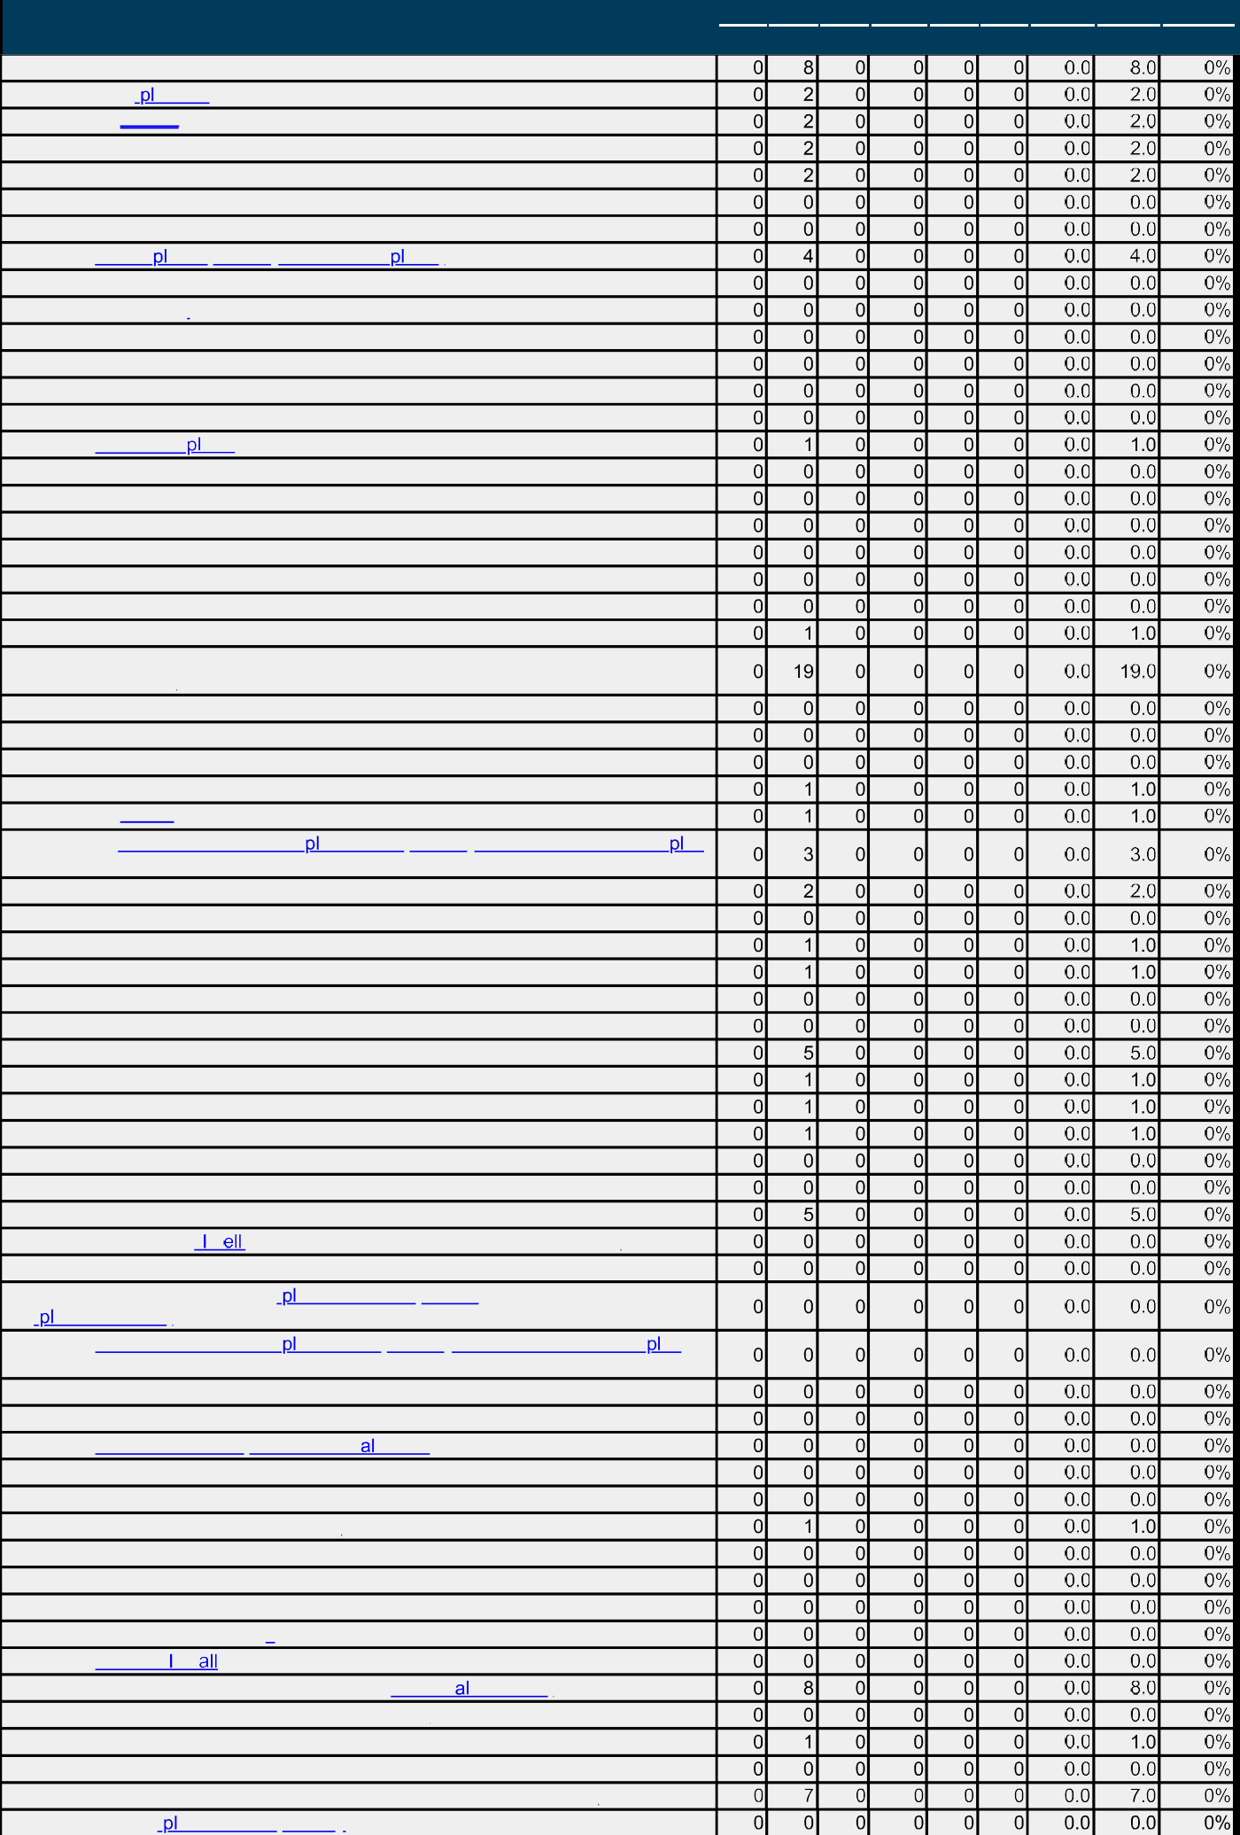

* + 1. Event Log Service
       1. Ap ication
       2. Security
       3. Setup
       4. System
    2. Event Logging
    3. Event Viewer
    4. File Ex orer (formerly Windows Ex orer)
       1. Previous Versions
    5. File History
    6. Find My Device
    7. Handwriting
    8. HomeGroup
    9. Human Presence
    10. Internet Ex orer
    11. Internet Information Services
    12. Location and Sensors
    13. Maintenance Scheduler
    14. Maps
    15. MDM
    16. Messaging
    17. Microsoft account
    18. Microsoft Defender Antivirus (formerly Windows Defender and Windows Defender Antivirus)
        1. Client Interface
        2. Device Control
        3. Exclusions
        4. Features
        5. MAPS
        6. Microsoft Defender Ex oit Guard (formerly Windows Defender Ex oit Guard).
           1. Attack Surface Reduction 18.10.43.6.2 Controlled Folder Access 18.10.43.6.3 Network Protection
        7. MpEngine
        8. Network Inspection System
        9. Quarantine
        10. Real-time Protection
        11. Remediation
            1. Behavioral Network Blocks 18.10.43.11.1.1 Brute-Force Protection 18.10.43.11.1.2 Remote Encry ption Protection
        12. Reporting
        13. Scan
        14. Security nt igence Updates (formerly Signature Updates) 18.10.43.15 Threats
    19. Microsoft Defender Ap ication Guard (formerly Windows Defender Ap ication Guard)
    20. Microsoft Defender Ex oit Guard (formerly Windows Defender Ex oit Guard)
    21. Microsoft Edge
    22. Microsoft Secondary Authentication Factor
    23. Microsoft User Experience Virtu ization
    24. NetMeeting
    25. News and interests
    26. OneDrive (formerly SkyDrive)
    27. Online Assistance
    28. OOBE
    29. Portable Operating System
    30. Presentation Settings
    31. Push To nst
    32. Remote Desktop Services (formerly Termin Services)
        1. RD Licensing (formerly TS Licensing)
        2. Remote Desktop Connection Client 18.10.57.2.1 RemoteFX USB Device Redirection
        3. Remote Desktop Session Host (formerly Terminal Server) 18.10.57.3.1 Ap ication Compatibility

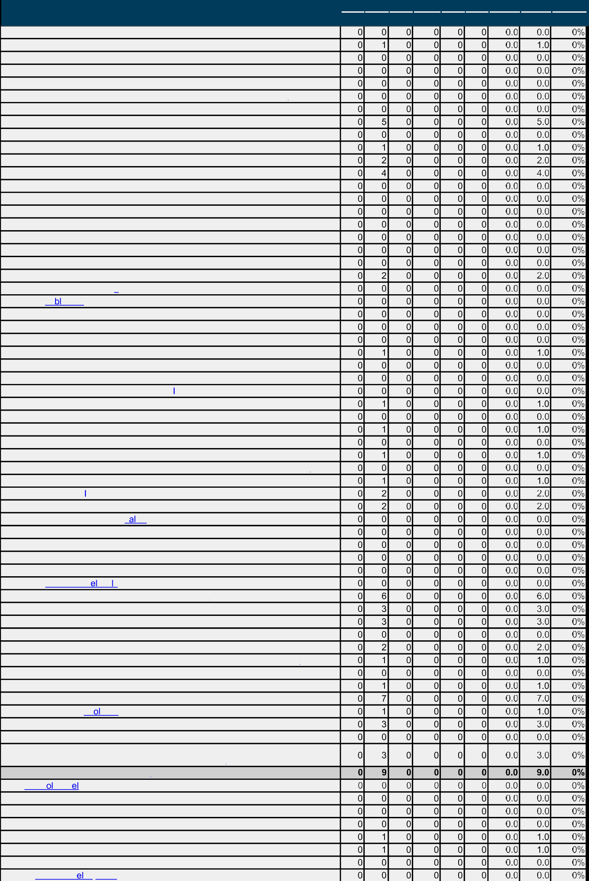

18.10.57.3.2 Connections

18.10.57.3.3 Device and Resource Redirection 18.10.57.3.4 Licensing

* + - * 1. Printer Redirection
        2. Profiles
        3. RD Connection Broker (formerly TS Connection Broker) 18.10.57.3.8 Remote Session Environment

18.10.57.3.9 Security 18.10.57.3.10 Session Time Limits 18.10.57.3.11 Temporary folders

* + 1. RSS Feeds
    2. Search
       1. OCR
    3. Security Center
    4. Shutdown Options
    5. Smart Card
    6. Software Protection Platform
    7. Sound Recorder
    8. Speech
    9. Store
    10. Sync your settings
    11. Ta et PC
    12. Task Scheduler
    13. Tenant Restrictions
    14. Text Input
    15. Widgets
    16. Windows Calendar
    17. Windows Color System
    18. Windows Customer Experience mprovement Program
    19. Windows Defender SmartScreen
        1. Enhanced Phishing Protection
        2. Explorer
    20. Windows Error Reporting
    21. Windows Game Recording and Broadcasting
    22. Windows Hello for Business (formerly Microsoft Passport for Work)
    23. Windows Ink Workspace
    24. Windows nstaller
    25. Windows Logon Options
    26. Windows Media Digit Rights Management
    27. Windows Media Player
    28. Windows Messenger
    29. Windows Mobility Center
    30. Windows PowerShell
    31. Windows R iabi ity Analysis
    32. Windows Remote Management (WinRM)
        1. WinRM Client
        2. WinRM Service
    33. Windows Remote Shell
    34. Windows Sandbox
    35. Windows Security (formerly Windows Defender Security Center)
        1. Account protection
        2. App and browser protection
    36. Windows Update
        1. Legacy P icies
        2. Manage end user experience
        3. Manage updates offered from Windows Server Update Service
        4. Manage updates offered from Windows Update (formerly Defer Windows Updates and Windows Update for Business)

1. **Administrative Templates (User)**
   1. Contr Pan
   2. Desktop
   3. Network
   4. Shared Folders
   5. Start Menu and Taskbar
      1. Notifications
   6. 3ystem
      1. Ctrl+Alt+D Options



|  |  |  |  |  |  |  |  |  |  |  |  |  |  |  |
| --- | --- | --- | --- | --- | --- | --- | --- | --- | --- | --- | --- | --- | --- | --- |
| 19.6.2 Disp_[ y | | | | | |  |  |  |  |  |  |  |  |  |
| 19.6.3 Driver Installation | | | | | |  |  |  |  |  |  |  |  |  |
| 19.6.4 Folder Redirection | | | | | |  |  |  |  |  |  |  |  |  |
| 19.6.5 Group P | | | icy | | |  |  |  |  |  |  |  |  |  |
| 19.6.6 Internet Communication Management | | | | | |  |  |  |  |  |  |  |  |  |
| 19.6.6.1 | nternet Communication settings | | | | |  |  |  |  |  |  |  |  |  |
| 19.7 Windows Components | | | | | |  |  |  |  |  |  |  |  |  |
| 19.7.1 Account Notifications | | | | | |  |  |  |  |  |  |  |  |  |
| 19.7.2 Add features to Windows 8 / 8.1 / 10 (formerly Windows Anytime Upgrade) | | | | | |  |  |  |  |  |  |  |  |  |
| 19.7.3 App runtime | | | | | |  |  |  |  |  |  |  |  |  |
| 19.7.4 Ap | ication Compatibility | | | | |  |  |  |  |  |  |  |  |  |
| 19.7.5 Attachment Manager | | | | | |  |  |  |  |  |  |  |  |  |
| 19.7.6 AutoPlay Policies | | | | | |  |  |  |  |  |  |  |  |  |
| 19.7.7 Calcu | | ator | | | |  |  |  |  |  |  |  |  |  |
| 19.7.8 Cloud Content | | | | | |  |  |  |  |  |  |  |  |  |
| 19.7.9 Credential User Interface | | | | | |  |  |  |  |  |  |  |  |  |
| 19.7.10 Data Collection and Preview Builds | | | | | |  |  |  |  |  |  |  |  |  |
| 19.7.11 Desktop Gadgets | | | | | |  |  |  |  |  |  |  |  |  |
| 19.7.12 Desktop Window Manager | | | | | |  |  |  |  |  |  |  |  |  |
| 19.7.13 Digital Locker | | | | | |  |  |  |  |  |  |  |  |  |
| 19.7.14 Edge UI | | | | | |  |  |  |  |  |  |  |  |  |
| 19.7.15 File Ex orer (formerly Windows Ex orer) | | | | | |  |  |  |  |  |  |  |  |  |
| 19.7.16 File Revocation | | | | | |  |  |  |  |  |  |  |  |  |
| 19.7.17 IME | | | | | |  |  |  |  |  |  |  |  |  |
| 19.7.18 Instant Search | | | | | |  |  |  |  |  |  |  |  |  |
| 19.7.19 Internet Ex orer | | | | | |  |  |  |  |  |  |  |  |  |
| 19.7.20 Location and Sensors | | | | | |  |  |  |  |  |  |  |  |  |
| 19.7.21 Microsoft Edge | | | | | |  |  |  |  |  |  |  |  |  |
| 19.7.22 Microsoft Management Console | | | | | |  |  |  |  |  |  |  |  |  |
| 19.7.23 Microsoft User Experience Virtu ization | | | | | |  |  |  |  |  |  |  |  |  |
| 19.7.24 Multitasking | | | | | |  |  |  |  |  |  |  |  |  |
| 19.7.25 NetMeeting | | | | | |  |  |  |  |  |  |  |  |  |
| 19.7.26 Network Sharing | | | | | |  |  |  |  |  |  |  |  |  |
| 19.7.27 OOBE | | | | | |  |  |  |  |  |  |  |  |  |
|  |  |  |  |  |  |  |  |  |
| 19.7.28 Presentation Settings | | | | | |  |  |  |  |  |  |  |  |  |
| 19.7.29 Remote Desktop Services (formerly Terminal Services) | | | | | |  |  |  |  |  |  |  |  |  |
| 19.7.30 RSS Feeds | | | | | |  |  |  |  |  |  |  |  |  |
| 19.7.31 Search | | | | | |  |  |  |  |  |  |  |  |  |
| 19.7.32 Snipping To | | | | | |  |  |  |  |  |  |  |  |  |
| 19.7.33 Sound Recorder | | | | | |  |  |  |  |  |  |  |  |  |
| 19.7.34 Store | | | | | |  |  |  |  |  |  |  |  |  |
| 19.7.35 Tablet PC | | | | | |  |  |  |  |  |  |  |  |  |
| 19.7.36 Task Scheduler | | | | | |  |  |  |  |  |  |  |  |  |
| 19.7.37 Windows | | | |  | |  |  |  |  |  |  |  |  |  |
| 19.7.38 Windows C | | | | | endar |  |  |  |  |  |  |  |  |  |
| 19.7.39 Windows C | | | | | or System |  |  |  |  |  |  |  |  |  |
| 19.7.40 Windows Copilot | | | | | |  |  |  |  |  |  |  |  |  |
| 19.7.41 Windows Defender SmartScreen | | | | | |  |  |  |  |  |  |  |  |  |
|  |  |  |  |  |  |  |  |  |
| 19.7.42 Windows Error Reporting | | | | | |  |  |  |  |  |  |  |  |  |
| 19.7.43 Windows Hello for Business (formerly Microsoft Passport for Work) | | | | | |  |  |  |  |  |  |  |  |  |
| 19.7.44 Windows Installer | | | | | |  |  |  |  |  |  |  |  |  |
| 19.7.45 Windows Logon Options | | | | | |  |  |  |  |  |  |  |  |  |
| 19.7.46 Windows Media Player | | | | | |  |  |  |  |  |  |  |  |  |
| 19.7.46.1 Networking | | | | | |  |  |  |  |  |  |  |  |  |
| 19.7.46.2 Playback | | | | | |  |  |  |  |  |  |  |  |  |
| **Total** | | | | | |  |  |  |  |  |  |  |  |  |

Note: Actual scores are subject to rounding errors. The sum of these values may not result in the exact overall score.

The ’Exe’ column only applies to Exceptions that are generated using CIS-CAT Pro Dashboard and is not utilized by CIS-CAT Pro Assessor.

**Profiles**

This benchmark contains 10 profiles.The Level 1 (L1) profile was used for this assessment.



This profile is for Corporate/Enterprise Environments and is considered general use.

Level 1 (L1)